# OWNML MACHINE LEARNING CANVAS Designed for: Designed by: Date: Iteration: .

|  |  |  |  |  |
| --- | --- | --- | --- | --- |
| PREDICTION TASKWhat is the type of task? Which entity are predictions made on? What are the possible outcomes to predict? When are outcomes observed?  Tipo: Clasificación binaria.  Unidad: solicitud individual de crédito.  Etiqueta: `kredit` (1 = buen pagador, 0 = mal pagador).  Plazo de observación: conjunto histórico del dataset | DECISIONSHow are predictions turned into actionable recommendations or decisions for the end-user? (Mention parameters of the process / application for this.)  Uso de la predicción: apoyo a la decisión de aprobar/condicionar/rechazar la aplicación de crédito. | VALUE PROPOSITIONWho is the end beneficiary, and what specific pain points are addressed? How will the ML solution integrate with their workflow, and through which user interfaces? El beneficiario principal es el área de riesgo de un banco hipotético.  En este caso, el cliente también se ve beneficiado por mejoras en el proceso de aprobación.  La solución final cobraría vida mediante una interfaz de usuario que llame a un servicio REST. | DATA COLLECTIONHow is the initial set of entities and outcomes sourced (e.g., database extracts, API pulls, manual labeling)? What strategies are in place to update data continuously while controlling cost and maintaining freshness? Fuente: dataset público South German Credit (UCI).  Recolección: archivos CSV provistos para la tarea (original y modificado).  No se realizará captura adicional; versión de datos documentada en el repositorio. | DATA SOURCESWhere can we get data on entities and observed outcomes? (Mention internal and external database tables or API methods.) `german_credit_original.csv` y `german_credit_modified.csv`.  Variables ejemplo: laufzeit (plazo), hoehe (monto), rate (cuota), alter (edad), etc.  Target balanceado 70/30 aprox.; el archivo modificado contiene ruido intencional. |
| IMPACT SIMULATIONWhat are the cost/gain values for (in)correct decisions? Which data is used to simulate pre-deployment impact? What are the criteria for deployment? Are there fairness constraints? Enfoque académico: comparación de métricas (ROC-AUC principal; Recall/F1 clase riesgosa).  Discusión cualitativa de trade-offs (FP vs FN) y del umbral elegido.  Sin análisis financiero/costo real. | MAKING PREDICTIONSAre predictions made in batch or in real time? How frequently? How much time is available for this (including featurization and decisions)? Which computational resources are used? Ámbito: ejecución en notebook (no productivo).  Predicciones: sobre partición de prueba/validación cruzada.  No hay requerimientos de latencia ni integración. |  | BUILDING MODELSHow many models are needed in production? When should they be updated? How much time is available for this (including featurization and analysis)? Which computation resources are used? Pipeline reproducible (sklearn): imputación → codificación → escalado → modelo.  Baselines: Regresión Logística y RandomForest (comparación justa en CV estratificada).  Sin tuning pesado; ajuste mínimo si ayuda a la interpretación. | FEATURESWhat representations are used for entities at prediction time? What aggregations or transformations are applied to raw data sources? Numéricas: escalado estándar; categóricas: One-Hot (handle_unknown='ignore').  Limpieza: normalizar `kredit`, podar espacios, convertir tipos mixtos.  Opcional: binning simple y ratios para exploración. |
|  | MONITORINGWhich metrics and KPIs are used to track the ML solution’s impact once deployed, both for end-users and for the business? How often should they be reviewed? | No aplica en producción; solo control de calidad del experimento.  Revisión de estabilidad por clase y reporte de matriz de confusión.  Registro de versiones de datos/notebook en el repositorio (académico). | |  |

|  |  |  |
| --- | --- | --- |
|  | Version 1.2. Created by Louis Dorard, Ph.D. Licensed under a [Creative Commons Attribution-ShareAlike 4.0 International License](https://creativecommons.org/licenses/by-sa/4.0/). Please keep this mention and the link to [ownml.co](https://www.ownml.co/) when sharing. | [**OWNML.CO**](https://www.ownml.co/) |

# 

# [FREE] ONLINE COURSE

# Introduction to the Machine Learning Canvas

Get started with the MLC in this short course taught by its author.

[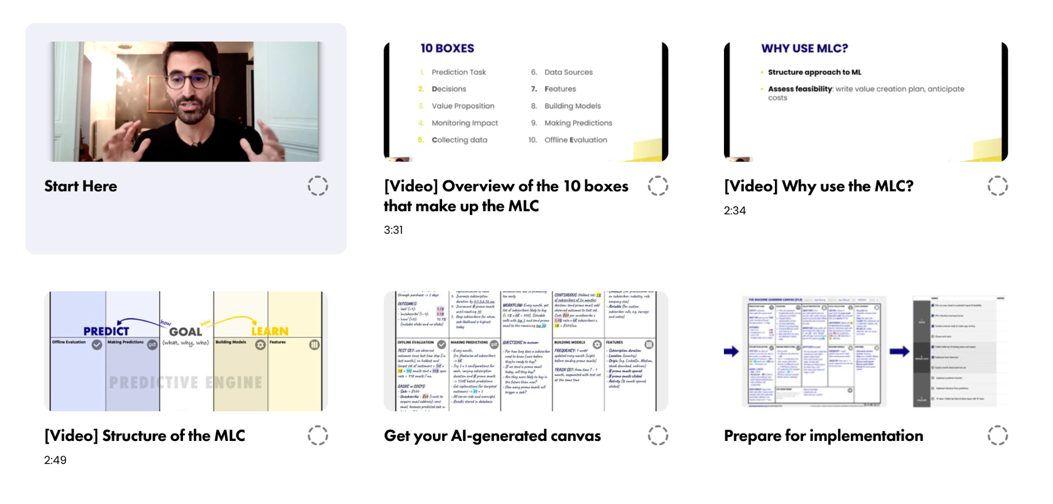](https://www.ownml.co/intro)

Start now at [**ownml.co/intro**](https://www.ownml.co/intro)